**Honor Board Accord: Fair or Foul?**

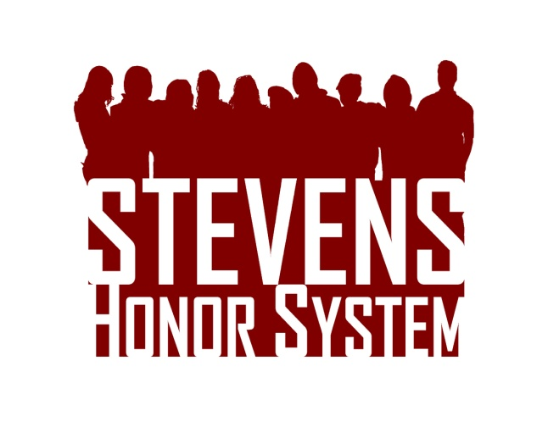Read the fake case presented to the Honor Board and determine whether a violation has occurred and what penalties should be assigned. Please support your reasoning. Visit [stevens.edu/honor](http://stevens.edu/honor) for the Honor System Bylaws and Penalty Matrix.  Drop your answers in Stevens mailbox S-1432 or email them to [honor@stevens.edu](mailto:honor@stevens.edu) by January 31st. The top response will receive a $50 Visa gift card!

A seating chart is passed around for the Circuits final. After being signed by every student, it is picked up by the TA. The TA notices faint penciling of all the True/False answers in the corner of the paper. After investigating, there are no leads on the person who wrote the answers on the seating chart, but one student comes forward confessing to copying them. Should any students be found guilty of an Honor System violation? If yes, what penalty should be assigned?